October 1st, 2006
Hi
Very little to write about this week. Only two entries in my diary.
Last Monday, I went for my one and only swim for the week. Intended to swim about 1.5 km but ended up doing 3 km! Monday was also the last major day of work on the Singapore science books before they are to be submitted to the Ministry of Education (tomorrow). These books are not new but are simply a revision of the old books for a revised syllabus. There is a lot of work involved just to keep in the same place.
On Tuesday, I went to the Tuen Mun clinic for two small biopsies on my back. Because they were small, slightly larger excisions were made so that, should the tests indicate they are malignant (cancerous), it is hoped that all the cancerous material has been removed and no further operation is needed. As a result of the operations, I didn't do any gym in the afternoon.
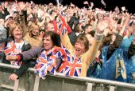

In evening listened to final hour of final night of the 2006 BBC proms. As well as the main concert in the Royal Albert Hall in London, there were similar concerts being held around the country. One of these was in Manchester in a park (see photo - called Heaton Park – heard of it Gavin?) Manchester also in the news as the Labour Party conference was held there which will be the last one for Tony Blair.


In Hong Kong, today is October 1st - National Day. It is the beginning of ‘Golden Week’ when large chunks of the population in China get a week’s holiday. The reasoning behind this is that by giving people a holiday, they will go out and spend, thus helping the economy. Apparently, it seems to work. October 1st would also have been Nana’s birthday. The Lantao cable car is in trouble again; it first had to stop for 40 minutes yesterday and later broke down with 450 people left suspended. Disneyland has also been in operation for a year and they announced the launch of annual passes, though they are very expensive, about twice the cost of Ocean Parks’ annual pass.
This coming Friday, I go to the clinic again to have the stitches removed. That day is also Mid-Autumn Festival day; because of using the lunar calendar, it is much later than usual. The festival is also mooncake time. To fill up this letter, I have added something on the history of the mooncakes (see below).
Cheers

History of mooncakes
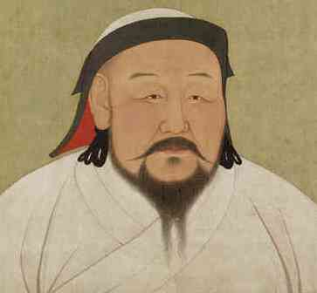
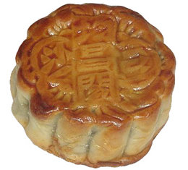
By the mid-thirteenth century, the Mongols under Genghis Khan and his grandson Kublai Khan (1215-94) had subjugated Northern China, Korea and the Muslim kingdoms of Central Asia and had twice penetrated Europe. During the Soong (Song) dynasty in the middle of the century, rebel leaders in China sought to overthrow the Mongol overlords. As meetings were banned, it was impossible to make meet to make plans. They came up with a plan by requesting permission to distribute cakes to bless the longevity of the Mongol emperor. Another story is that a rumour was spread that a plague was ravaging the land and that only by eating a special mooncake could the disaster be prevented. Either way, thousands of cakes shaped like the moon and stuffed with sweet fillings were made. Inside each cake however was placed a piece of paper with the message: ‘Rise against the Tartars on the 15th day of the 8th Moon’. The cakes were only distributed to the Han Chinese people. Reading the message, the people rose against the Mongols on a local scale. This initial rebellion eventually led to the overthrow of the Mongols in 1368 and the establishment of the Ming dynasty, which lasted for about 300 years.
Kublai Khan

